

University of Sharjah
College of Computing and Informatics
Computer Science Department

Junior Project Final Report


Nexly: An LLM-Powered Chatbot for Student Advising

Zyead Ahmad
Theyab Mohammed
Niaz Mahmud
Abdullah Almazzmi

U22106802
U21100918
U21102204
U21102590

Supervisor: Dr. Bouziane Brik
April 2025

Table Of Contents
Acknowledgements | 4
Abstract | 5
General Introduction  - The Need for AI-Driven Academic Support  Introducing Nexly : A Smart Academic Assistant  - Multi-Platform Accessibility | 6
Literature Review  - Existing Campus Assistants  - AISHA – Zayed University  - UAEU Bot – UAE University  - UC Berkely – Student Central Chatbot  - BARKPLUG V.2 – Mississipi State University | 9
Data Collection and Processing  - Extract web pages and pdf’s links and store them in .txt file  - Read the links and iterate over them  - Use llamaIndex to fetch the content from pdf’s | 11
Workflow of Nexly Chatbot  - Why RAG for Nextly-Chatbot  - Basic Terminology  - Architecture Of Our Core RAG Model  3.1 Document / Text Processing  3.2 Embedding Creation  3.3 Embedding Storage  3.4 Embedding Comparison and Similarity Calculation  3.5 Pass the retrieved “Chunks” in LLM model  3.6 Confidence Scoring for User Queries | 12
Model UML Diagrams  - System Use Case Diagram  - State Diagrams  - Embedding Engine State Diagram  - Data Preprocessing State Diagram  - Document Storing State Diagram  - Class Diagram | 17
Model Evaluation Methodology  - Query 1: MBA Program Tuition and Payment Plans  - Query 2: : PhD in Arabic Language Course Structure  - Technical Implementation and Areas of Improvement | 20
Nexly Mobile  - Why a Mobile-First Academic Assistant?  - Design Philosophy & Human-Centred Objectives  - System Overview  Workflow and Component Architecture  - UI and Main Components  - AI Services Summary  - Error Handling Strategy  - More on Features and Precautions  - Future Directions | 23
Nexly Web  - Why a Web-Based Academic Assistant?  - System Overview: Frontend and Backend  - FrontEnd Architecture  - Backend Architecture  - User Interface  - Future Direction for Nexly Website  - UML Diagrams  - Class Diagrams  - State Transition Diagrams | 30
Conclusion  What We Achieved  Why It Matters  Honest Limitations  Where We Go Next  Final Thoughts | 36
References | 38
Acroymns Table | 39

Acknowledgements
We would like to extend our deepest gratitude to all those who supported us throughout the journey of developing the first versions of Nexly.
First and foremost, our sincere thanks go to our supervisor, Dr. Bouziane Brik, and our college dean, Dr. Abbes Amira, for their continuous guidance, insightful feedback, and encouragement at every stage. Their mentorship played a crucial role in shaping this project and pushing us to aim higher.
We also want to thank the College of Computing and Informatics at the University of Sharjah for providing us with the resources, academic support, and a collaborative environment that allowed this project to grow.
A heartfelt thank you to our families and friends for their endless patience, moral support, and belief in us even during the most stressful moments. Your encouragement kept us going.
Finally, a big shoutout to our team — Zyead Ahmad, Theyab Mohammed, Niaz Mahmud, and Abdullah Almazzmi — for the late nights, the brainstorming sessions, the technical debates, and the shared vision. Nexly wouldn’t have become a reality without each member’s commitment and passion.

Abstract
This project presents the first version of Nexly, an intelligent academic assistant powered by Large Language Models (LLMs), built to support students with academic advising and university-related queries. As universities grow in size and complexity, students often face challenges accessing timely, consistent, and personalized academic support. Nexly addresses this by offering a conversational AI interface capable of delivering multilingual, context-aware assistance across both web and mobile platforms.
Nexly is not a generic chatbot—it is tailored for higher education. The system leverages Google’s Gemini 2.0 Flash for prompt handling and generation on mobile, integrated with Exa.ai for enhanced web scraping and search results. Meanwhile, our web version explores a more advanced architecture using a Retrieval-Augmented Generation (RAG) and Llama 3.3 Language Model pipeline, combining vector databases and LLM inference to provide grounded and accurate responses. This dual approach emerged due to technical constraints and platform-specific challenges.
The development of Nexly included sourcing and preprocessing data from university handbooks, policies, webpages , and student guides. Manual and synthetic Q&A pairs were generated, and semantic deduplication was applied to ensure relevance. Throughout this process, special care was taken to protect our data, secure API keys, and follow ethical AI design practices.
While this version of Nexly is still under active development until the final implementation in our senior phase of the project, and has not been fully deployed, it serves as a strong basis for future iterations. A basic testing framework, and a modular architecture have been implemented to support scalability, iteration, and long-term improvement. Initial feedback suggests high potential for practical adoption in real academic settings.
In essence, this version of Nexly demonstrates the feasibility of LLM-powered academic support tools and lays the groundwork for a fully integrated digital advising, registeration, and an overall university experience that is scalable, secure, and student-centered.

General Introduction

In today’s rapidly evolving academic ecosystem, students are increasingly expected to independently manage complex university systems, from course planning and registration to understanding academic policies and navigating administrative requirements. However, despite the availability of digital platforms and self-service portals, students often struggle with fragmented information, unclear procedures, and inconsistent communication with advisors. These challenges are amplified in large institutions where student-to-advisor ratios are high, leading to long wait times, limited appointment availability, and impersonal guidance. The consequences of this gap include delayed graduations, missed opportunities, academic probation, and increased frustration and disengagement among students.
As higher education continues to digitize, the need for intelligent, scalable, and accessible academic support systems has never been more critical. Students now demand more than static FAQ pages or hectic ticket-based support—they expect personalized, real-time assistance that understands their unique academic context and speaks their language, literally and figuratively. This demand calls for a paradigm shift in how academic advising and university communication are delivered.
At the intersection of this demand and innovation stands Nexly—a smart academic assistant designed to revolutionize student support using the capabilities of artificial intelligence. Unlike generic chatbots or limited decision-tree systems, Nexly harnesses the power of Large Language Models (LLMs) and Retrieval-Augmented Generation (RAG) to provide students with meaningful, accurate, and context-aware assistance on-demand.
While this report details the development journey of Nexly, it’s important to note that this is the first officially working version of the system—a Minimum Viable Product (MVP) that already demonstrates key capabilities such as conversational academic advising, smart recommendations, and dual-platform accessibility via web and mobile applications. The MVP serves as both a proof of concept and a launchpad for future expansion and our senior project, including tighter university integrations—if possible, adaptive learning models, and advanced personalization features.
This introduction section outlines the motivations behind Nexly, the gap it addresses in current university systems, and the technological opportunity presented by AI to create not just a chatbot, but a truly intelligent companion for every student’s academic journey.

The Need for AI-Driven Academic Support
The traditional model of academic advising, though rooted in personalized guidance, has increasingly shown signs of strain as university’s students’ populations grow and course structures become more complex and dynamic. Manual advising systems often depend on fixed schedules, limited staff, and static documentation creating bottlenecks in support delivery that fail to keep up with real-time student needs. For many students, especially those navigating course selections, graduation requirements, or university policy changes, timely access to accurate academic advice can be the difference between academic success and delay or dropout.
While some institutions have adopted self-service platforms or basic FAQ bots to mitigate this issue, these solutions often fall short in personalization, adaptability, and natural communication. They operate within rigid frameworks, unable to understand nuanced questions or provide context-specific answers. Moreover, such systems are often confined to a single topic and do not accommodate the diverse needs of student communities.
This is where Artificial Intelligence (AI) particularly Large Language Models (LLMs) offers a transformative advantage. LLMs, trained on vast corpora of structured and unstructured text, have demonstrated an unprecedented ability to understand, generate, and adapt language in ways that mimic human interaction. Their ability to deliver context-aware, conversational, and domain-specific responses makes them uniquely suited for the challenges of academic advising.
Nexly harnesses this power to fill a longstanding gap in higher education: the lack of an intelligent, real-time, multilingual academic assistant that can operate across platforms and evolve with institutional needs. With the rise of generative AI, we’re no longer limited to static databases—we can now build systems that actively learn from data, adapt to feedback, and deliver personalized guidance at scale.
The current MVP of Nexly demonstrates how AI can move beyond support automation and become a proactive part of the student journey—bridging the gap between information systems, academic policy, and human-centered advising.

Introducing Nexly: A Smart Academic Assistant
Nexly is more than just a chatbot—it’s a student-centric, AI-powered academic assistant designed to bring intelligent support directly into the hands of university students. Developed as a response to the growing need for smarter academic services, Nexly combines Large Language Models (LLMs), Retrieval-Augmented Generation (RAG), context-aware prompting, and modern UI/UX design to offer a seamless, scalable solution that can operate across platforms and languages.
At its core, Nexly aims to function as a virtual academic advisor, available 24/7, capable of handling a wide range of student needs—from course planning and registration to understanding academic policies, deadlines, and administrative workflows. Unlike traditional FAQ bots that follow decision trees or simple keyword matching, Nexly understands the intent, context, and nuance of user input, generating personalized, informed and well-structured responses that reflect institutional knowledge and student-specific variables.
With this first MVP version, Nexly already supports multiple key features:
- Real-time conversational interface that mirrors a human advisor on steroids.
- Threaded chat memory on mobile, preserving context across queries and keeping conversations well-informed.
- Integration with RAG on web and Web Scraping on mobile, for intelligent document retrieval and more accurate answers on both platforms.
- AI pipeline using Gemini 2.0 & Llama 3.3, transforming vague or casual queries into structured, optimized prompts.
- Cross-platform availability, with both mobile and web versions tailored to the student experience.

Multi-Platform Accessibility
To ensure Nexly is accessible anytime, anywhere, we developed it across both web and mobile platforms, each with its own tailored technical approach—driven by practical limitations and the opportunity to experiment with different AI workflows.
On the web version, we implemented a Retrieval-Augmented Generation (RAG) pipeline powered by Meta’s LLaMA 3.3, paired with a custom vector store. This allowed for grounded, document-based responses with local control over retrieval and generation, ideal for academic queries tied to structured university resources.
On the mobile side, and since we can’t run ai on mobile phones – yet, we leveraged Exa.ai an intelligent web scraping and retrieval tool, integrated with the latest Google’s Gemini 2.0 Flash for fast, context-aware response generation. This mobile-first approach prioritized responsiveness and low-latency interaction while maintaining conversational depth and context awarness.
This split allowed us to explore and compare multiple architectures, models, and data-handling strategies—enhancing our team’s exposure to modern AI stacks, prompting methods, and cross-platform design patterns. It not only improved Nexly’s capabilities but significantly strengthened our technical versatility moving forward.

Litreture Review

As universities increasingly adopt digital transformation strategies, AI-powered chatbots have emerged as promising solutions to improve student services. Several institutions around the world have developed and deployed intelligent assistants to support students with tasks such as academic advising, campus navigation, and administrative queries. This section reviews existing systems relevant to Nexly, evaluating their capabilities, limitations, and technical approaches.

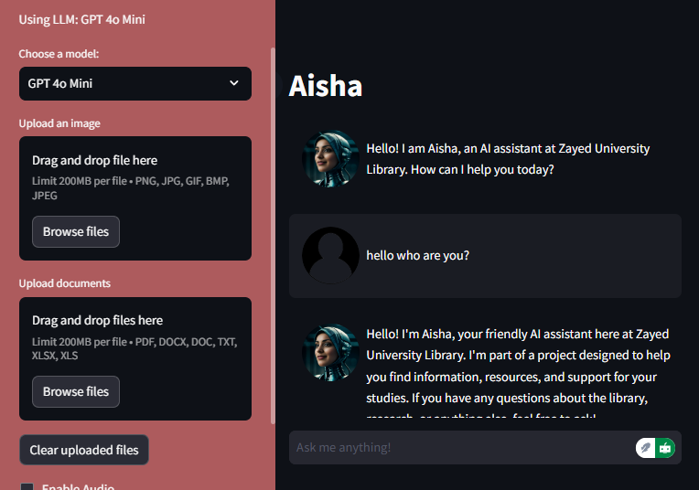
2.1 Existing Campus Assistants
Figure 2.1: aisha chatbot interface showcasing its conversational interaction and introduction. built with openai’s gpt models

AISHA – Zayed University
AISHA (Artificially Intelligent Super Helpful Assistant) is a domain-specific chatbot developed by Zayed University Library to enhance reference service (Figure 2.1). It uses OpenAI’s models with Python and integrates tools like speech recognition, Wikipedia, the ZU catalog, and Google Search. One of its unique features is its ability to display its "thought process" to users, boosting transparency and digital literacy.
Technically, AISHA was built using LangChain for LLM orchestration, Chroma for vector-based retrieval, and Streamlit for frontend deployment. It employs function calling for tool integration, showcasing strong multi-source retrieval and advanced reasoning capabilities.

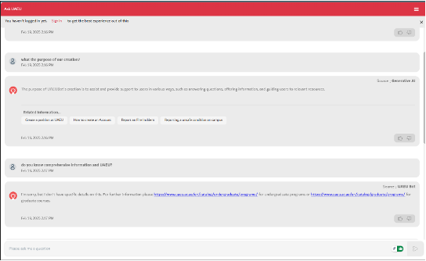
UAEU Bot – UAE University

Figure 2.2: snapshot of the uaeu bot answering real-time academic and administrative questions.
UAEU Bot is a conversational agent developed to simplify access to university-related services (Figure 2.2). It offers voice and text-based interaction, providing students with academic info (GPA, grades), administrative details (campus services, schedules), and IT support. Integrated with institutional databases, it delivers personalized results and automates common service requests.
Although the bot is functional and practical, its conversational depth and personalization appear limited to predefined queries and structured data, lacking the dynamic context adaptation offered by LLMs.

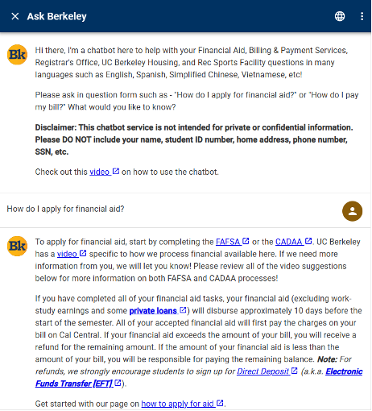
Cal Student Central Chatbot – UC Berkeley

Figure 2.3: a view of the berkeley’s chatbot guiding students through financial aid applications.
UC Berkeley’s Cal Student Central Chatbot serves as an automated assistant focused on financial aid, enrollment, billing, and other admin services (Figure 2.3). It’s designed to reduce human workload by addressing frequently asked questions 24/7 through a rule-based and database-connected system.
Despite being highly useful in reducing queue times and admin load, this chatbot primarily handles transactional queries and lacks a learning model, making it less adaptive to nuanced or evolving academic needs.

BARKPLUG V.2 – Mississippi State University
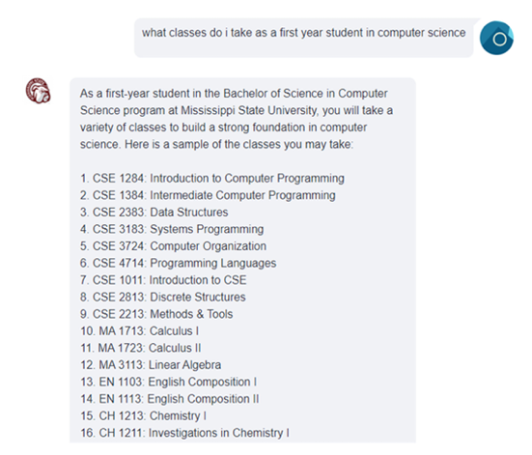
BARKPLUG V.2 stands out for implementing a Retrieval-Augmented Generation (RAG) pipeline for its academic assistant chatbot (Figure 2.4). It supports general academic inquiries across campus departments and utilizes vector search for context-specific answers. While not much is detailed about its UI/UX, the technical stack mirrors emerging best practices for scalable AI assistants in academia.

Figure 2.4: the barkplug chatbot responding to a first-year computer science student with a detailed academic plan. Powered by a RAG pipeline, it retrieves course structures and personalized recommendations from internal university datasets.
This model closely aligns with Nexly's web implementation and demonstrates the potential of RAG-based workflows in education.

Data Collection and Processing

Primarily, we have extracted all the contents and pdfs from University of Sharjah website, this process consists of 3 steps:
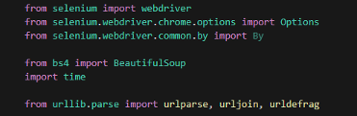
Figure 3.1: imports and libraries used in extraction codes of the pdf’s and webpages

3.1 Extract web pages and pdf’s links and store them in .txt file(It is done for future purpose)
As our university website is dynamic, we have used selenium to load all the content of a web page at once and download the links and save then in txt file, and the crawling outputs is show in Figure 3.2
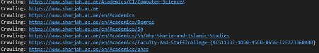
3.2 Read The links and iterate over them
Figure 3.2: showing output of crawled webapges links
Then fetch all the content (just HTML content, skipped reading JavaScript content and Style and other attributes for cleaner layout to be fed to the RAG Model – later)
3.3 Use llamaIndex to fetch the content from pdf’s
Here, we are fetching and reading the downloaded pdf’s and storing them in a .txt file according to pdf title as metadata.

Workflow of Nexly Chatbot

Our “Nexly AI” is for now based on a RAG methodology. RAG consists of 3 major parts, Retrieval-Augmented-Generation.
- Retrieval: Seeking relevant information from a source given a query. For example, getting relevant passages of Wikipedia text from a database given a question.
- Augmented: Using the relevant retrieved information to modify an input to a generative model (e.g. an LLM).
- Generation: Generating an output given an input. For example, in the case of an LLM, generating a passage of text given an input prompt.

4.1 Why RAG for Nexly-Chatbot?
The main goal of RAG is to improve the generation outputs of LLMs. Main primary improvements can be seen as:
- Preventing hallucinations - LLMs are incredible but they are prone to potential hallucination, as in, generating something that looks correct but isn't. RAG pipelines can help LLMs generate more well-informed outputs by providing them with factual inputs. And even if the generated answer from a RAG pipeline doesn't seem correct, because of retrieval, you also have access to the sources where it came from.

- Work with custom data - Many large-scale LLMs are trained with internet text data. This means they have a great ability to model language, however, they often lack specific knowledge. RAG systems can provide LLMs with domain-specific data such as a company documentation and thus customize their outputs to suit specific needs.

4.2 Basic Terminology

- Token: It is a part of word or sub-word or can be a word. Ex: “university of Sharjah” can be split into [“university”, “of”, “Sharjah”], so each of them can be identified as token so sub-part of word can be a token.
For our embedding model, “multi-qa-mpnet-base-dot-v1” uses 4 word = 1token

- Embeddings: A numerical representation of a part or a piece of data or sentence. For our model, “multi-qa-mpnet-base-dot-v1” convert a sentence to vector of size= (768,)

- Context Window: It refers a few token that an LLM model can take/process as input. For ChatGPT its default context window size is = 32k token but can be extended to 128k token if needed. For out model (in free limit) it provides

4.3 Architecture Of Our Core RAG Model
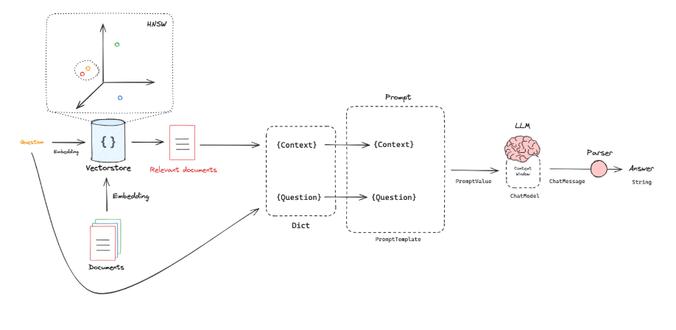
Figure 4.1 : Architecture of the Retrieval-Augmented Generation (RAG) model used in Nexly. The system retrieves relevant documents via vector search, ranks them, and combines the retrieved context with the user's query to generate accurate, grounded responses through a large language model (LLM).

This diagram illustrates the architecture of Nexly's Retrieval-Augmented Generation (RAG) model. The process begins with a user question, which is embedded into a vector space via a VectorStore for similarity search. Relevant documents are retrieved based on semantic proximity and passed through a re-ranking step to ensure the most contextually aligned information is selected. These documents, along with the original question, form the input prompt. The prompt is then sent to the LLM (e.g., LLaMA), which uses this enriched context to generate a well-informed, grounded answer. This hybrid approach ensures that the final response is not only fluent but also factually backed by trusted institutional data.

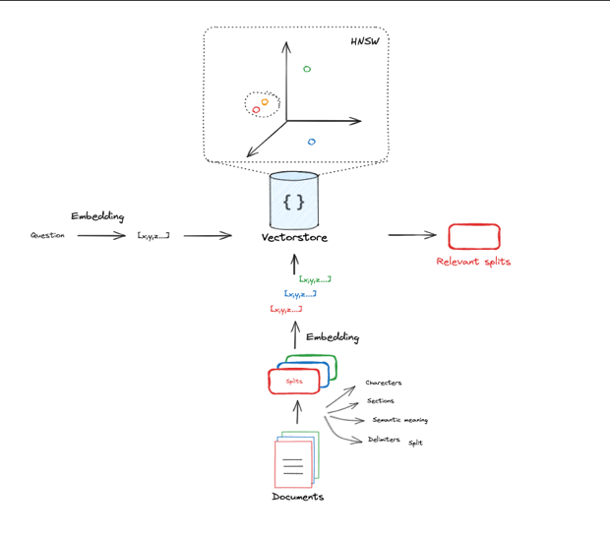
4.3.1 Document / Text Processing
Figure 4.2 : Chunking and embedding workflow used in Nexly’s RAG-based document retrieval. Unstructured documents are divided into 250-word chunks, embedded into a vector store, and ranked based on semantic similarity to user queries before being passed to the LLM.
In Figure 4.2, we visualize the chunking and embedding pipeline used for document retrieval in Nexly’s RAG model. The system begins by collecting a stack of unstructured data, such as web-scraped content or internal university documents. These documents are preprocessed into chunks of 250 words each—a size carefully chosen based on the token limits of the Groq API's free tier, which offers a context window of 6,000 tokens.
To ensure that both input and output can be accommodated, the system reserves up to 2,048 tokens for output, leaving 3,952 tokens for input context. Since each token approximately maps to 4 characters, this allows a maximum input size of 15,808 characters. By selecting the top 10 most semantically relevant chunks (each ~250 words, or about 1,250 characters), the total input size becomes approximately 12,500 characters, leaving sufficient room for instructions and prompt formatting. This setup ensures efficient use of the context window while maintaining high response quality.

4.3.2 Embedding Creation
Once the raw documents are segmented into manageable 250-word chunks, each chunk is transformed into a dense numerical representation, known as an embedding. These embeddings capture the semantic meaning of each chunk, allowing for meaningful similarity comparisons during retrieval. For this task, we use the open-source model multi-qa-mpnet-base-dot-v1 from Hugging Face’s Sentence Transformers library. This model is specifically fine-tuned for semantic search, trained on diverse (question, answer) pairs to effectively link queries with contextually relevant passages. Each processed chunk is embedded into a fixed-length vector of 768 dimensions, preserving the relationships between words and phrases in a format that is machine-comprehensible and optimized for similarity search.

4.2.3 Embedding Storage
At the current stage of development, Nexly processes and embeds over 300,000 text chunks. To manage this efficiently without overengineering the infrastructure, we store the resulting embeddings in CSV files. This approach is lightweight and suitable for experimentation and early-scale deployment. However, as the system scales—particularly when the number of embeddings exceeds 1 million—a more robust solution will be required. At that point, we plan to transition to a dedicated vector database, such as FAISS, Weaviate, or Pinecone, which will offer faster indexing, scalable search capabilities, and real-time vector similarity retrieval for user queries.

4.2.4 Embedding Comparison and Similarity Calculation
When a user submits a query, the system encodes it into a 768-dimensional vector using the same embedding model used during the document preprocessing phase—multi-qa-mpnet-base-dot-v1. To identify relevant content, the system performs a dot product similarity operation between the query embedding and the precomputed document embeddings.
As illustrated in Figure 3.5, both the query and document embeddings are arrays of 768 values. The similarity between two embeddings is calculated using the cosine similarity formula, which is the dot product of the two vectors divided by the product of their magnitudes:
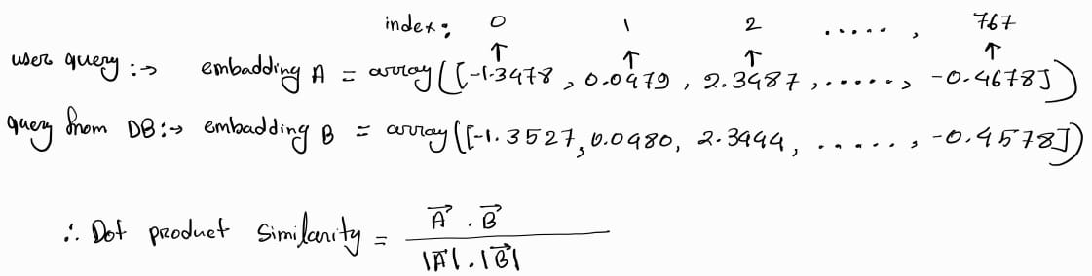
Figure 4.3: Cosine similarity calculation between the user query embedding and document embeddings. The dot product operation helps retrieve the top semantically relevant chunks from the vector store for the RAG pipeline.

$$Similarity=\frac{\overline{A} ∙ \overline{B} }{\left\|\overline{A}\right\| ∙ \left\|\overline{B}\right\|}$$
This mathematical operation returns a similarity score between -1 and 1, where higher scores indicate stronger semantic relevance. Based on these scores, Nexly selects the top 10 most similar chunks to be used as supporting context during the final response generation by the LLM. After retrieving the chunks related to user query, then our model sends all the data in a state-of-the-art LLM model using API to re-structure and fetch the content from those chunks and user query.

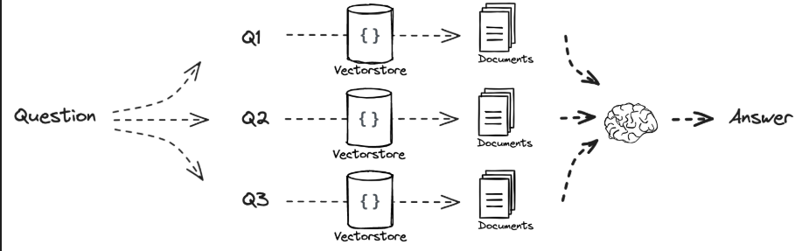
4.2.5 Pass the retrieved “Chunks” in LLM model:

After retrieving the top 10 most similar chunks regarding to user query, then our model send all these data in a state-of-the-art LLM model using API to re-structure and fetch the content from those chunks regarding to the user query.

4.2.6 Confidence Scoring for User Queries
Once the LLM generates a restructured response based on the retrieved context, Nexly performs an additional confidence verification step to ensure the output is relevant and grounded. This is done by embedding the generated response and reapplying a dot product similarity test between the query and the output embeddings—leveraging the same semantic space used in earlier stages.
If the similarity score (i.e., confidence) is greater than 0.60, the response is considered semantically aligned with the user’s intent and is delivered via API to the Nexly web or mobile app. However, if the confidence score falls below 0.60, the system refrains from presenting potentially irrelevant or vague answers. Instead, it prompts the user to rephrase their query and ensure it is more specific and aligned with topics related to the University of Sharjah. This confidence gate helps maintain response quality, filters out hallucinated outputs, and guides users toward clearer, more effective interactions.

Model UML Diagrams

4.3 System Use Case Diagram
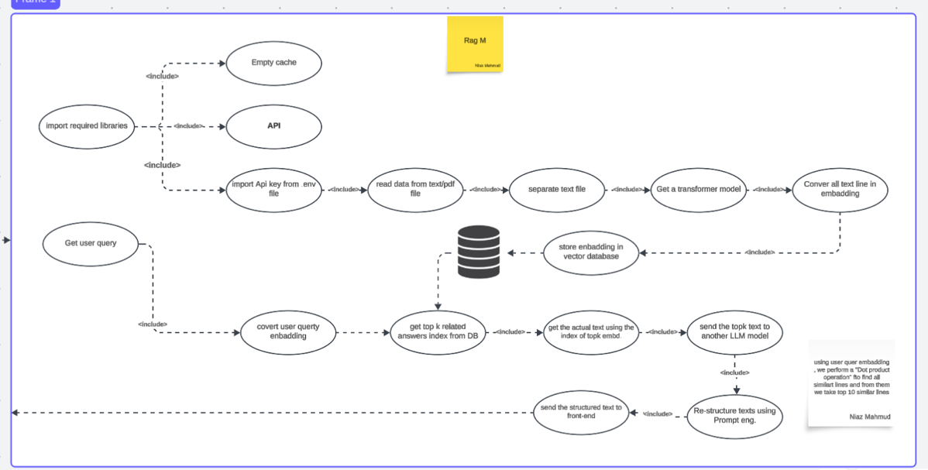
Figure 4.3.1: System-level use case of Nexly’s web-based rag pipeline. It outlines the process from receiving a user query, passing it through an api and validation layers, retrieving semantically ranked documents, performing confidence checks, and returning either a validated response or a user prompt for query refinement.

4.4.1 Embedding Engine State Diagram
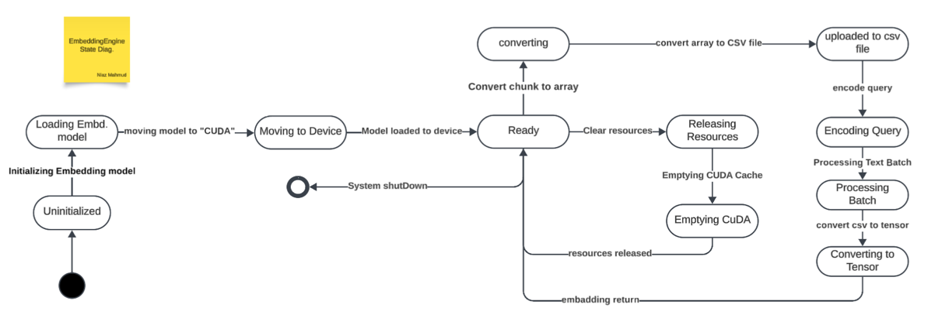
Figure 4.4.1: Embedding system flow from model loading to encoding and storing vectors, including device allocation and CSV export.

This diagram outlines the embedding pipeline initialization process, starting with the model loading phase and progressing through memory management, resource allocation, and eventual encoding of text data into tensor format for embedding. The system dynamically offloads data to GPU, processes it in batches, and exports embeddings into a CSV for future similarity queries

4.4.2 Data Preprocessing State Diagram
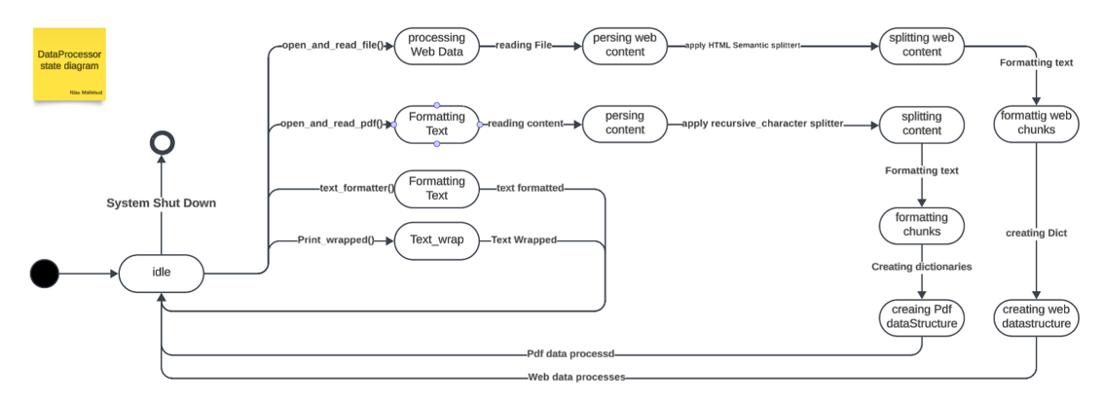
Figure 4.4.2: Data ingestion flowchart showing separate processing tracks for web and PDF content, including semantic splitting, formatting, and structure creation prior to embedding.

This state diagram outlines Nexly's data preprocessing engine, which starts in an Idle state and can dynamically handle both web data and PDF documents through two parallel pipelines. For web data, the system parses HTML content, applies semantic splitters, and converts the processed input into structured web-friendly formats. In the case of PDFs, the engine formats text, applies recursive character-based splitting, and builds structured representations suitable for embedding. Each path includes stages for content cleaning, formatting, and labeling—ensuring uniformity across diverse data sources before vectorization.

4.4.3 Document Storing State Diagram
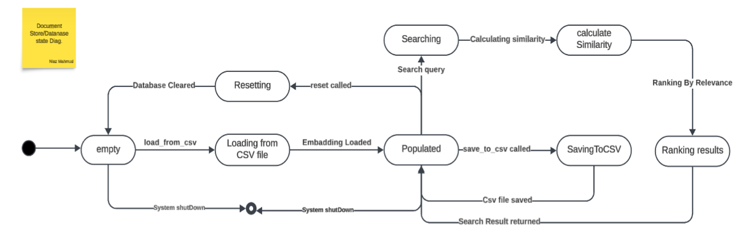
Figure 4.4.3: Embedding store state flow for loading, searching, ranking, and managing document vectors within Nexly's system.

This state diagram illustrates the document embedding store logic in Nexly’s backend. The system starts in an Empty state and transitions to Populated after loading embeddings from CSV files. In this central state, several key operations become available, including similarity-based searching, CSV export, and database reset. When a query is received, the system computes similarity scores between the query and stored embeddings, ranking the results by relevance before returning them. The design also includes reset and shutdown paths, ensuring robust management of the in-memory embedding store.

4.5 Class Diagram
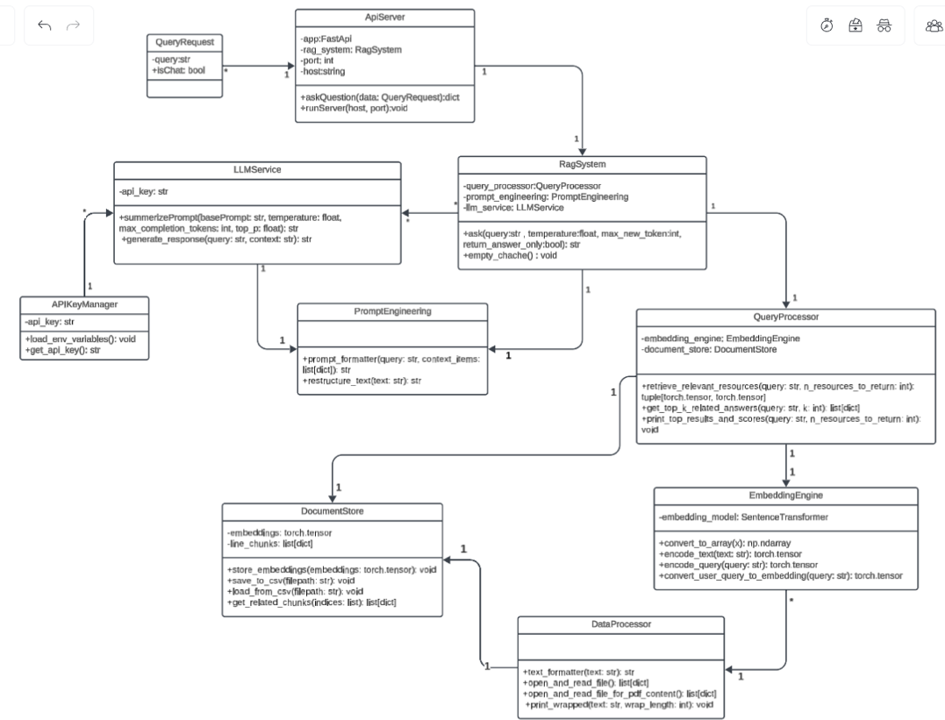
Figure 4.5: UML class diagram of Nexly’s RAG system, showing modular interactions between API handling, embedding generation, prompt engineering, and document storage.

This UML diagram outlines the core class structure of Nexly’s RAG-based architecture. The design emphasizes modularity, separating responsibilities across components such as API handling, prompt creation, embedding generation, and document storage.
- APIKeyManager handles the secure loading and management of API credentials from environment variables, encapsulating all logic related to external access tokens and authentication.
- EmbeddingEngine is responsible for managing the SentenceTransformer model, transforming both documents and queries into vector embeddings. It also includes functionality for chunking raw documents and preparing them for similarity matching.
- DocumentStore serves as the central repository for both raw text chunks and their embeddings. It supports saving embeddings to persistent formats (e.g., CSV) and provides semantic search capabilities for retrieving relevant content.
- LLMService interfaces with external large language model APIs. It handles prompt submission, manages key hyperparameters like temperature and token limits, and processes streamed model outputs.
- PromptEngineering focuses on crafting structured, context-rich prompts by merging user queries with retrieved document snippets, ensuring optimized inputs for LLM inference.
- APIServer implements the web-facing FastAPI layer that exposes Nexly’s RAG system through RESTful endpoints. It handles request validation via models like QueryRequest and connects client input to backend processing logic.

Model Evaluation Methodology

The evaluation assesses how well the retrieved contexts align with the query semantically and how the final answer compares to both the query and contexts. This is measured using cosine similarity between vector embeddings:
- Query-Context Similarity: Measures how relevant each retrieved context is to the original query.
- Query-Answer Similarity: Measures how well the generated answer aligns with the original query.
In this section we’ll showcase 2 test cases, many others were done in real-life.

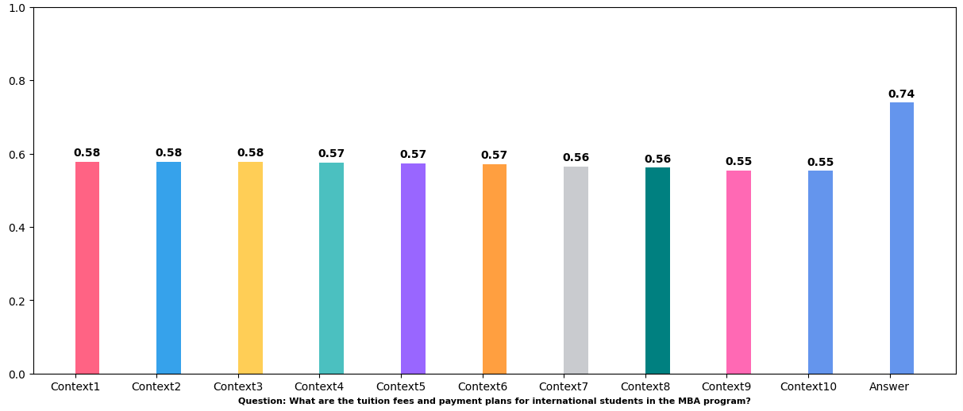
5.1.1 Query 1: MBA Program Tuition and Payment Plans
Figure 5.1.1: Comparison of cosine similarity scores between the query and retrieved context chunks versus the final generated answer. The final answer shows markedly higher semantic alignment.

This bar chart illustrates the semantic similarity scores between the user query and each retrieved context chunk, as well as the final answer generated by the model. Most context chunks fall within a tight similarity range of 0.55 to 0.58, reflecting consistent but moderately relevant support. Notably, the final answer achieves a score of 0.74, indicating a substantial semantic improvement after processing and rephrasing by the LLM. This showcases a 27.6% boost in relevance, demonstrating the effectiveness of the RAG pipeline and prompt engineering in synthesizing higher-quality responses from mid-relevance context.

5.1.4 Query 2: : PhD in Arabic Language Course Structure
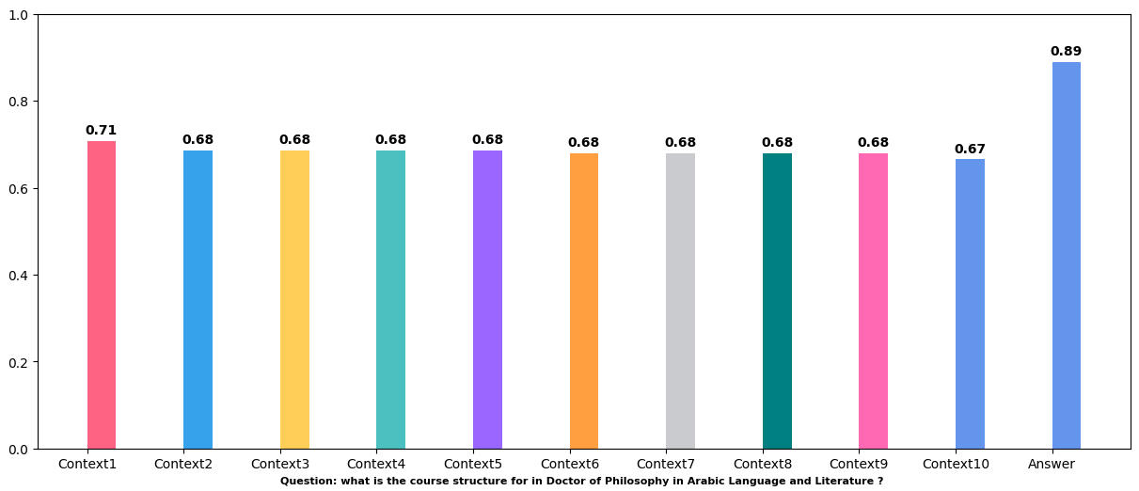
Figure 5.1.2: Semantic similarity comparison for a query about the PhD in Arabic program, showing the boost in relevance from retrieved contexts to the generated answer.

2/2

This figure presents the semantic similarity scores for a user query regarding the course structure of the PhD in Arabic Language and Literature program. Among the retrieved contexts, Context 1 demonstrated the highest initial similarity at 0.71. However, after applying Nexly's RAG and prompt engineering pipeline, the final generated answer reached a score of 0.89, marking a 25.4% semantic improvement. This highlights the model's ability to synthesize and elevate relevance beyond the individual input chunks, producing a significantly more aligned and informative output.

5.2 Technical Implementation and Areas of Improvement
The evaluation framework behind Nexly’s RAG system integrates several key technologies to assess and synthesize responses effectively. Embeddings are generated using the open-source Sentence-Transformers library, specifically the multi-qa-mpnet-base-dot-v1 model. Cosine similarity is employed to quantify semantic relevance between user queries, retrieved contexts, and the generated responses. The response generation itself is handled by Groq’s mistral-saba-24b large language model (LLM), with backend operations running on PyTorch for efficient tensor manipulation via CUDA. Visual insights such as similarity score comparisons are plotted using Matplotlib, and random sampling from a larger evaluation set is used to simulate real-world usage conditions.
However, several limitations were identified during development and evaluation. First, the evaluation was strictly quantitative, relying solely on similarity metrics. This excluded qualitative evaluation frameworks like RAGAS, llamaIndex, Langsmith, or Giskard, which use proprietary LLMs such as OpenAI or LLAMA for grading response quality. Since these tools depend on paid or restricted APIs, their integration was not feasible under our current resource model.
Additionally, the choice of embedding model presents constraints. While multi-qa-mpnet-base-dot-v1 is suitable for general semantic search, it lacks the deep contextual understanding and accuracy of newer, proprietary encoders from OpenAI or Meta. As a result, the system sometimes fails to grasp nuanced or complex sentence structures, limiting its performance on less direct queries.
The dataset scope also narrows performance. Our current data was sourced exclusively from public-facing content on the University of Sharjah website. This limits coverage of internal student services or academic policy nuances. Collaboration with university administration to gain access to richer and more representative datasets is a critical next step.
Finally, several advanced improvements could significantly elevate Nexly’s capabilities. These include fine-tuning a dedicated LLM on University of Sharjah-specific data to enhance contextual alignment and accuracy. Furthermore, transitioning to an advanced RAG architecture, such as Corrective RAG, could greatly improve handling of vague or poorly phrased questions. Instead of prompting users to rephrase queries when confidence scores are low, Corrective RAG pipelines attempt to autonomously rephrase the query, re-run the retrieval and generation steps, and return an improved answer—making the system more intelligent and user-friendly.
Overall, while the current implementation is functional and promising, targeted upgrades in data access, model quality, and evaluation methodology could transform Nexly into a best-in-class academic assistant.

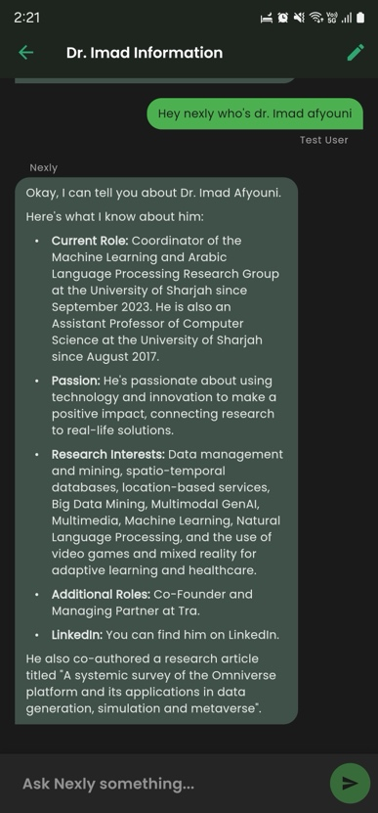
Nexly Mobile

Figure 6.1: a view of the nexly chatbot asnwering an inquiry about a faculty member in uos

6.1 Why a Mobile-First Academic Assistant?
While the preceding chapters discuss architectural choices at a high level, this section zooms in on how Nexly works on a smartphone.
Higher-education ecosystems are becoming hyper-complex digital cities. Students must keep pace with rolling registration windows, prerequisite chains, frequent policy revisions, scholarship criteria, mental-health resources, and more. Traditional support models—walk-in advising, static FAQ pages, or siloed self-service portals—crack under that weight, especially at institutions where the advisor-to-student ratio exceeds 1 : 50.
Mobile devices, on the contrary, are always in a student’s pocket. They host calendars, ID cards, payment apps, and social networks. Embedding personalised academic intelligence in that same channel transforms the phone into a 24/7 mini-advisor—one that remembers context, speaks the student’s language, and answers within seconds rather than days.
This chapter deep-dives into how Nexly Mobile realises that ambition through a human-centred, security-aware, and performance-constrained design.

Paradigm / Principle | Application in Nexly Mobile
Constructivist Learning Theory (Piaget, 1970) | Chat threads let students construct knowledge through dialogue and reflection rather than passively reading FAQs.
Activity Theory (Engeström, 1987) | Each use-case (e.g., ScheduleGroupMeeting) is modelled as an activity system with clear subject, tool, rules, and outcome nodes, ensuring the UI maps to authentic student goals.
Human-in-the-Loop AI | The AI generates answers, but students steer the conversation; ambiguous queries trigger clarifying questions rather than opaque guesses.
Mobile HCI Best-Practices (Nielsen, 2020) | ≥ 44 px tappable targets, dark-mode parity, and haptic feedback on critical actions (e.g., message sent).

6.2 Design Philosophy & Human-Centred Objectives
• Empathy over Efficiency — a five-second delay that yields a caring answer is preferable to a sub-second, robotic response.
• Transparency by Default — the formatter appends a “Last updated” timestamp and source snippet to every policy answer, letting the student verify authenticity.
• Progressive Disclosure — advanced features (group-rename, access-control lists) remain hidden until a user demonstrates need, keeping the surface minimal for newcomers.

6.3 System Overview

Layer | Technology | Purpose
Frontend | Flutter (Dart) | UI, state management, device integration
State | Riverpod | Reactive state & dependency injection
Storage | SharedPreferences | Persist user settings, threads, messages
AI Backend | Google Gemini + Exa.ai | Query optimisation, UOS-specific search, structured responses
Analytics/Logging | Dart logging | Debugging & performance metrics
CI/CD | GitHub Actions | Automated build, test, deploy
The Nexly Mobile App architecture is designed around a modular, layered structure that ensures maintainability, scalability, and high responsiveness. At the frontend, Flutter (Dart) powers the user interface and handles device integration, delivering a visually appealing, platform-consistent experience across both iOS and Android. Riverpod serves as the state management solution, enabling fine-grained reactivity, dependency injection, and context-safe state handling across views and user sessions.
For data persistence, the app employs SharedPreferences, storing essential user settings, conversation threads, and cached messages locally to allow seamless recovery and offline fallback. AI functionality is driven by a dual integration of Google Gemini for conversational reasoning and Exa.ai for deep-domain-specific search—together forming a pipeline where user queries are first optimized via Gemini, enriched with UOS-relevant documents from Exa, and finally answered through Gemini with contextual awareness. This backend is carefully structured to maintain a balance between performance and personalization, with query-specific constraints and fallback strategies built-in.
The app also features Dart-based logging for tracking runtime behavior and debugging events, paving the way for future remote analytics and monitoring. Continuous Integration and Delivery (CI/CD) is handled through GitHub Actions, streamlining build, test, and deploy cycles. This workflow ensures that any update, whether functional or cosmetic, passes quality checks before reaching users—maintaining stability as the app evolves through future enhancements like real UOS API integration and push notifications.

6.4 Workflow and Component Architecture
The architecture of Nexly Mobile follows a clean separation of concerns, built around a three-layer model: presentation, domain, and data. The system’s query-response workflow, as illustrated in the high-level diagram, begins when a student inputs a message into the Flutter-powered UI. This input is immediately sent to Google’s Gemini API, where the message is semantically optimized into a structured, search-oriented query using temperature-controlled prompting. This step ensures that vague or informal student questions are transformed into a precise, relevant format.
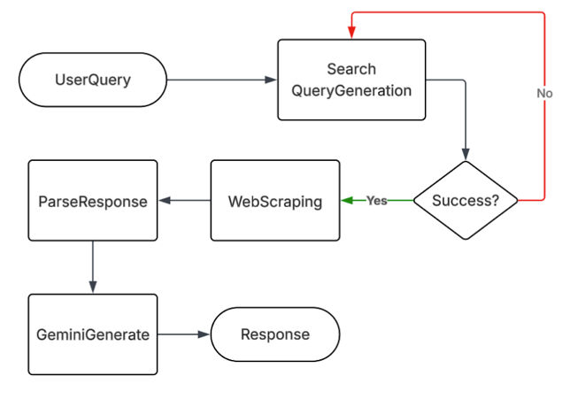
Once optimized, the query is passed to Exa.ai, which performs a real-time semantic search across domains constrained to uos.ac.ae and sharjah.ac.ae. It fetches up to eight contextually ranked documents, which are then routed back to Gemini, along with the last ten messages from the thread and the original user query. Gemini synthesizes a Markdown-formatted, context-aware response, which includes tables, lists, or rich text if needed, ensuring a conversational yet informative answer. This final response is then rendered in the chat interface, with rotating loading texts keeping the user engaged during the generation process.

Figure 6.2: the systematic workflow of nexly mobile, demonstrated by a flowchart showcasing how a resopnse generation works.
From an architectural standpoint, the presentation layer—developed with Flutter—contains all UI screens such as the chat interface, thread management, onboarding/login flow, study groups, and profile/settings views. These interact with the domain layer, where the core business logic resides. Repositories like GeminiRepo, ExaSearchRepo, and ThreadRepo abstract the data sources, while services such as ChatService, ScheduleService, and the mock AuthService orchestrate workflows and state changes. This is supported by Riverpod notifiers (CurrentChatThreadNotifier, etc.) that maintain real-time reactivity across the app.
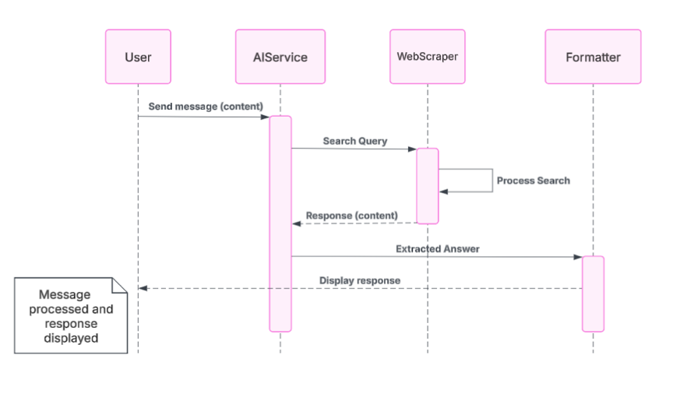
Finally, the data layer is composed of local persistence mechanisms—primarily SharedPreferences, which stores JSON-encoded data including saved threads and user settings. Mock data for schedules and study groups are also used during development, with future provisions for integrating official UOS APIs, calendar systems, and the BlackBoard LMS. This layered approach ensures the system is modular, testable, and easily extensible as new features and real data sources come into play.

Figure 6.3: the systematic workflow of nexly mobile, demonstrated by a sequence diagram showcasing how a resopnse generation works.
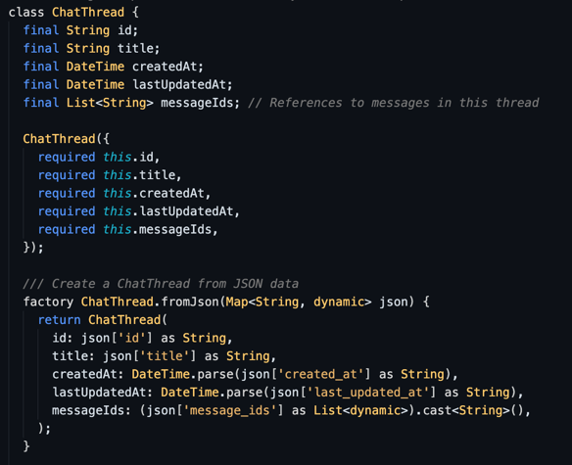
So in short as shown in Figure 6.3, the user journey begins when a message is submitted through the ChatInputField, which triggers the ChatService.sendMessage() function to initiate the AI interaction. The message is first sent to Google Gemini with a low-temperature parameter (0.2) to optimize the query for semantic search. This optimized query is then passed to Exa.ai, which conducts a focused search across the uos.ac.ae and sharjah.ac.ae domains, returning up to eight ranked results limited to 3000 characters each, spanning a three-year content range. If Exa fails, the system gracefully falls back to retrial. Next, the original user input, along with the Exa.ai search results and the last ten messages in the thread, are forwarded back to Gemini at a slightly higher temperature (0.3) to generate a contextual, markdown-formatted response. This response, which may include structured tables or code blocks, is rendered in the chat UI with loading indicators for user feedback during processing. Each message is saved locally using SharedPreferences under its thread ID, and if it's a new thread, the title is stored after a short delay to prevent race conditions. In case of any errors—whether API failure or local I/O issues—the app provides user-friendly fallback mechanisms like cached responses, mock answers, or error banners to maintain a smooth experience.

Figure 6.4: the main code of the chat thread class, showcasing contrcutor and the json factory funciton in dart

6.5 UI and Main Components

The chat interface is managed through ChatScreen it serves as the core interaction point in Nexly (see Figure 6.1), while interacting the service is maintaining a memory of the last ten messages to ensure context-aware replies. It displays rotating loading indicators to keep users informed during AI processing. Thread titles are updated safely post-first-response, with mounted checks and delayed guards preventing race conditions in data modification.

Thread management is handled through ChatThread, enabling full CRUD operations (create, read, update, delete) as shown in Figure 6.4. Threads are sorted by recent activity, and users can swipe to delete. Titles are generated by AI with a fallback to “New Chat” if the generation fails. All actions are atomic, ensuring message links stay intact.
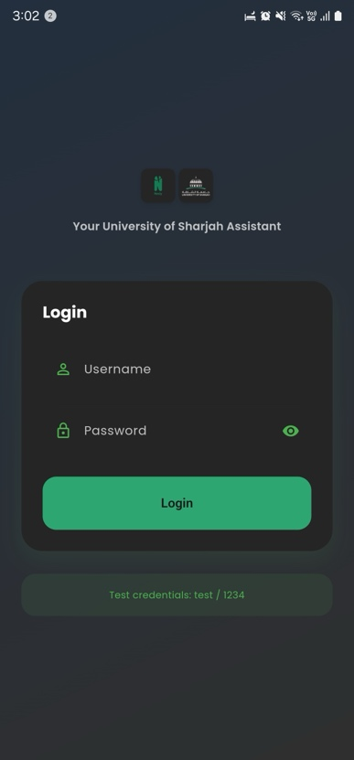
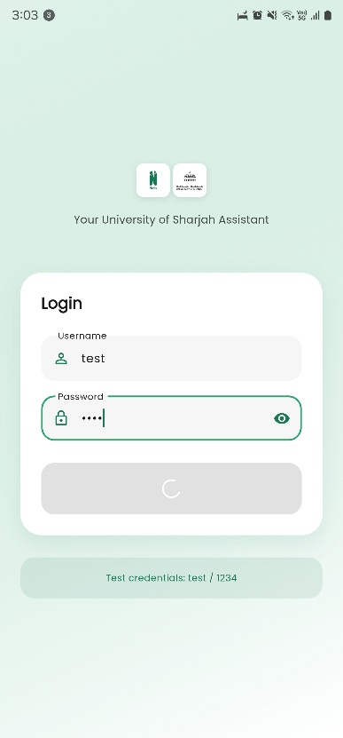
The onboarding flow and mock login screen (Figure 6.5) provide a streamlined start for users, with a presonalized dark/light theme colros based on the user mobile phone default. One of the most worked-on features of the app is the loading layouts and interactions’ feedbacks, since it’s heavily a network-dependant experience. A hardcoded user list (e.g., test/1234) is used for testing, with form validation and error toasts enhancing the user experience. Upon login, mock tokens and profile details are securely stored in SharedPreferences.

Figure 6.5: a view of the nexly app login screen welcoming the user in their system theme

The schedule screen (Figure 6.6) displays hardcoded – for now, course data in a clean banner format, showing upcoming classes like. It connects seamlessly with the chat module—students can ask natural questions like “When is my next class?” and get AI responses linked to this view.

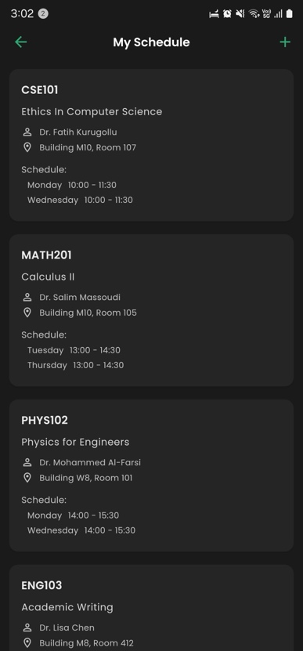
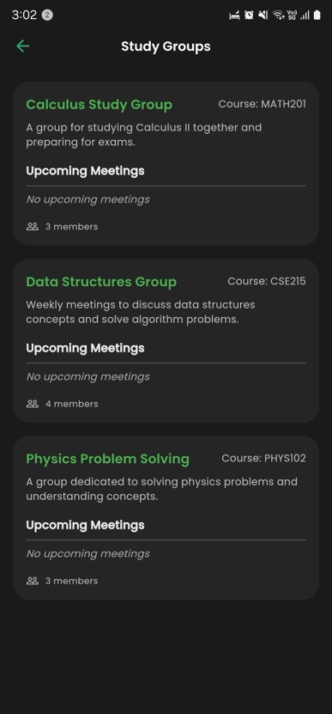
Study groups are shown in a filterable list format (Figure 6.7), allowing users to find and engage with mock – for now, groups easily. Each group has a button that opens a related chat, enabling immediate group discussions.

Figure 6.6: a view of the nexly app schedule screen showing the user their upcoming classes in a tidy clean ui

Figure 6.7: the nexly app group screen showing the user their study groups and allowing intercations in a clean ui and easy ux

The profile and settings module offers user customization options including theme switching (light/dark), language toggle (multilingual support planned and to be added in the future), notifications control, legal screens, and secure logout. All changes persist through SharedPreferences, giving users a smooth and consistent experience across sessions.

6.6 AI Services Summary
Nexly’s intelligent responses rely on a streamlined AI pipeline with clearly defined roles for each service:
- Gemini Optimiser is the first step in the chain, refining the user’s input into a search-optimized query. It operates with a conservative temperature of 0.2 to preserve intent, with a 30-second timeout and two retry attempts for reliability.
- Exa.ai follows by performing a semantic search across UOS-specific domains (uos.ac.ae, sharjah.ac.ae). It returns up to 8 ranked results within a 3-year data window. If Exa times out (20 seconds), the system falls back to mock data for continuity.
- Gemini Responder uses the original query, past messages, and Exa results to generate a markdown-formatted, context-rich response. It operates at a slightly higher temperature of 0.3 for fluidity, with safeguards like content length limits and structured output formatting.
- A custom system prompt is injected on every call to ensure consistent tone, memory behavior, and embedded user rules—guaranteeing outputs that are aligned with Nexly’s academic and conversational objectives.

6.7 Error Handling Strategy
Nexly implements a robust, multi-layered error handling framework designed to preserve user experience even under failure conditions. When a network connection drops, a Connectivity() listener detects the issue and notifies the user with a banner stating, “Offline – showing cached info.” In this case, previously stored chats are shown from local storage to maintain continuity.
If an API call exceeds its timeout threshold, the system triggers a snackbar alert with a retry option (to be implemented), while a mock response is displayed to prevent disruption. In cases where Exa.ai returns client (4xx) or server (5xx) errors, the system checks the status codes and displays a friendly fallback message. Instead of failing entirely, the response is generated by Gemini using only the chat context, bypassing the search step.
To avoid issues during rapid thread updates, a combination of mutex locking and mounted widget flags ensures race conditions are silently recovered from, with atomic rewrites maintaining data integrity. For SharedPreferences read/write failures, the system catches exceptions, followed by an automatic retry.
All errors are systematically logged with timestamps, stack traces, and device metadata to enable future analysis and integration with remote logging systems (e.g., firebase analytics)

6.8 More on Features and Precautions
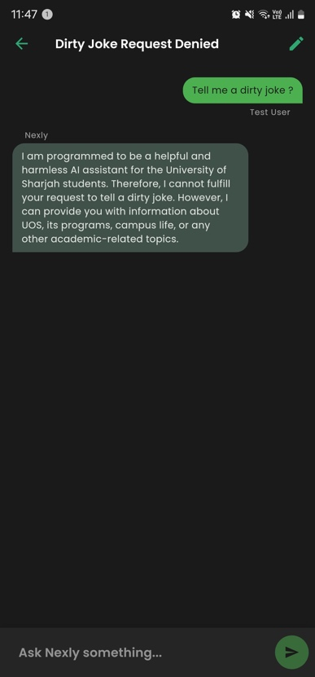
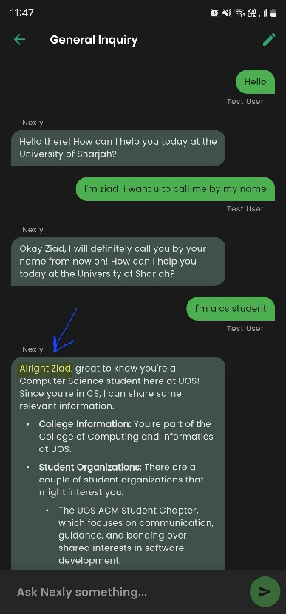
The two screenshots as shown in Figure 6.8 demonstrate key pillars of Nexly’s design: context awareness and ethical safeguards. In the first screenshot, Nexly accurately remembers and addresses the user by their preferred name (“Ziad”) and adapts its response based on the user’s academic background as a Computer Science student—showcasing dynamic personalization and thread-level memory. This illustrates how Nexly goes beyond generic chatbots, offering tailored, empathetic interactions rooted in the user’s identity and academic context. In contrast, the second screenshot highlights Nexly’s built-in inappropriate use handling. When prompted for a "dirty joke," the system immediately rejects the request in a professional, non-confrontational manner, reinforcing its role as a responsible, university-aligned assistant focused solely on academic and student support topics.

Figure 6.8: a view of the nexly chat feature keeping context and denying inappropriate usage from a user

6.8 Future Directions
As Nexly continues to evolve beyond its MVP stage, several strategic enhancements are planned to elevate it from a robust prototype to a fully integrated, institution-grade academic assistant. A major future direction involves aligning the mobile version with the web app's advanced architecture, specifically by adopting a Retrieval-Augmented Generation (RAG) pipeline. This would enable the mobile app to generate even more accurate, grounded, and explainable responses by retrieving and referencing real university documents in context—mirroring the capabilities currently available on the Nexly web platform.
Another critical objective is the integration with the University of Sharjah’s Single Sign-On (SSO) system, enabling secure, centralized authentication. This will allow users to log in using their university credentials and unlock access to personalized data such as course schedules, grades, and academic records through real UOS APIs.
Beyond architectural improvements, the roadmap also includes push notifications, voice input using Speech-to-Text, Arabic/English localization (via easy_localization), and offline functionality through SQLite caching. Additional planned integrations cover LMS systems, university email, a dashboard for usage analytics, and social features for study groups. To ensure security, the team also plans to utilize third-party vaults for managing API keys and secrets in production environments.
These directions aim to ensure Nexly is not just a smart chatbot, but a core part of every student’s academic journey—scalable, personalized, and tightly integrated with institutional systems.

Nexly Web

7.1 Why a Web-Based Academic Assistant?

While the mobile app offers a highly integrated, always-available academic assistant experience, the web version of Nexly serves as a complementary interface that focuses on ease of access, scalability, and future extensibility. Here's why we chose to launch on the web:
- Immediate Accessibility: Users can access Nexly instantly from any browser without needing to download an app. This is particularly valuable for new users, guest sessions, or quick inquiries during lectures or advising sessions.
- Scalable MVP Deployment: The initial web release focuses on core functionality—query input and RAG-based AI responses—without requiring login or registration. This MVP design enables faster iteration and testing while reducing complexity during early stages.
- Future-Ready Architecture: The frontend is designed with extensibility in mind. As the platform evolves, features such as user accounts, chat history and file-based queries can be integrated seamlessly without major refactoring.
- Device-Agnostic Usage: The web app ensures Nexly is usable across laptops, tablets, and public terminals. It provides a consistent, responsive experience that complements the mobile app by addressing scenarios where desktop input and multitasking are preferred.

7.2 System Overview: Frontend and Backend
Frontend Architecture:
- Framework: React.js – A component-based JavaScript library that allows for modular, responsive Uis.
- Styling: Pure CSS with CSS Variables – Enables dynamic theming (light/dark mode) and responsive layout adjustments.
- State Handling: Managed via useState and useEffect hooks for input tracking, theme toggling, and screen resizing.
- User Interface:
- Chat Interface: Divides messages into user (right-aligned) and AI (left-aligned) threads.
- Theme Toggle: Respects system theme and allows user override.
- Typing Feedback: Includes animated dots to indicate the AI is processing a response.
- Responsive Design: Layout and sidebars adjust based on screen size for optimal mobile and desktop usability.

Backend Architecture

- Model API: Custom LLAMA-3.3 70B server (RAG pipeline) served via a local network or static IP.
- Communication: Uses Axios for POST requests, sending JSON payloads.
The app communicates with a running model on a defined IP : “http://192.168.x.x:8709/askQuestion/”,
Future iterations may integrate user authentication, database persistence, and cloud scalability.

Layer | Technology | Future Plan
API Endpoint | Local/Private IP to LLAMA-3.3 RAG | Will migrate to hosted endpoint with authentication & logging
Model | RAG Pipeline via FastAPI | Add query analytics, caching, failover strategy
Database | Not Yet Implemented | Persist user settings, threads, messages
AI Backend | Google Gemini + Exa.ai | To be added for storing users, chats, preferences and user info
File Upload | UI Present, Inactive | File-based context retrieval with OCR/PDF parsing

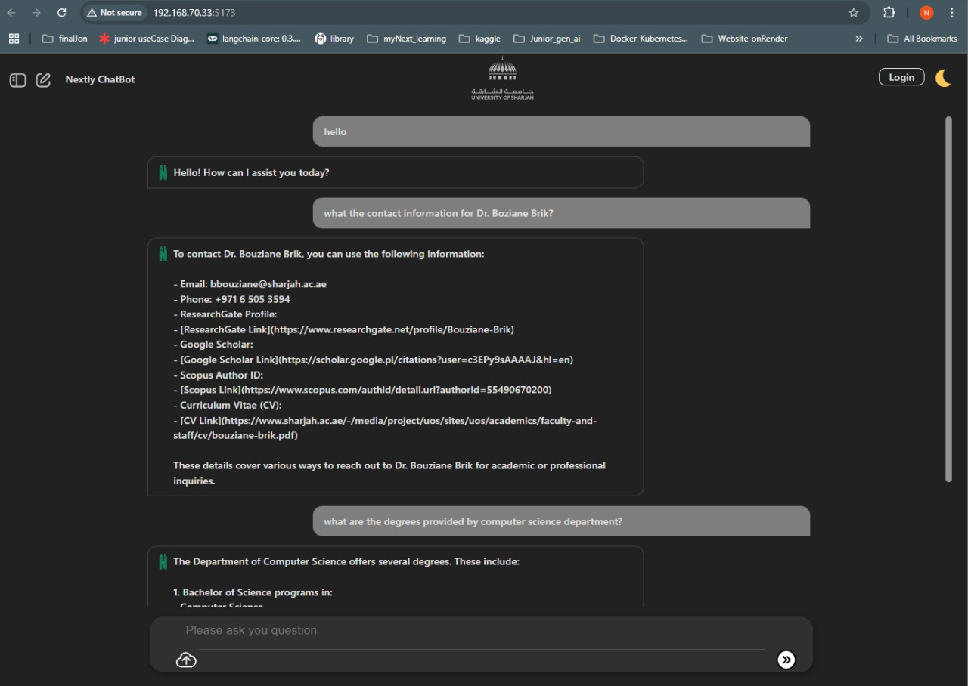
7.3 User Interface

Figure 7.1: a view of the nexly chat interface for the web platform

The user interface of Nexly is designed to be user-friendly, minimalistic and intuitvie, making it easy to use for the average university students and facuilty members to interact with the AI. Nexly features a simple chat window where users can type their prompts or questions about either general, specific or detailed information about University of Sharjah.
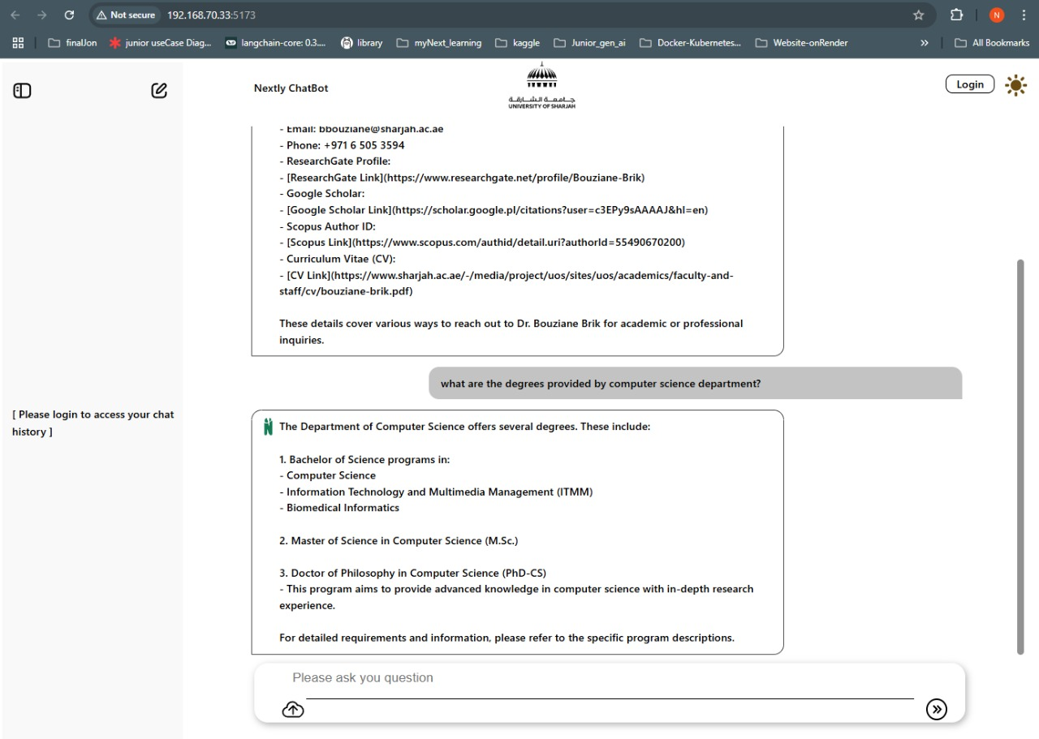
Additionaly, the interface offers both dark and light modes for visual comfort, moreover, Nexly includes conversation history, allowing users to access and follow-up on previous interactions and queries. Overall, Nexly user interface was design by prioritizing accessibility and ease of use to uplift the user experience.

Figure 7.2: a view of the nexly chat interface with different themes

7.4 Future Direction for Nexly Website

Nexly will undergo a number of strategic improvements as it moves past its MVP stage, turning it from a solid prototype into an all-inclusive, university-level online academic aide. By collecting and referencing authentic university materials, this method enables Nexly to provide incredibly accurate, contextually aware, and explicable responses, so reinforcing its position as a reliable academic partner. The smooth integration with the University of Sharjah's Single Sign-On (SSO) system, which enables users to safely authenticate using their university credentials, is another key goal. Through real-time communication with UOS APIs, this integration will provide for tailored access to academic data, including course schedules, grades, and records.
Along with backend improvements, the roadmap calls for full Arabic/English translation powered by easy_localization, voice input using Speech-to-Text, and push alerts through the browser. Browser-based caching techniques will be used to provide offline support, guaranteeing dependable access in settings with poor connectivity. Additional features that are planned include social tools for study group formation, university email, a web-based dashboard for usage data, and connectivity with LMS systems. Nexly will use third-party vault services to manage API keys and secrets in production environments in order to adhere to security best practices.

With these tactical advancements, Nexly hopes to establish itself as a vital, scalable, and customized web platform that is intricately woven into the educational process, going beyond simply being a clever academic aid.

7.5 Class Diagram

The following diagram represents the main architecture of Nexly Website, highlighting the interaction that occurs between various components such as user authentication, chat session management, main interface, and response generation. Several Key components include User, UserAuthentication, ChatHistory, ChatSession, MainInterface, AiResponseGenerator, MessageDisplay and SideBar.
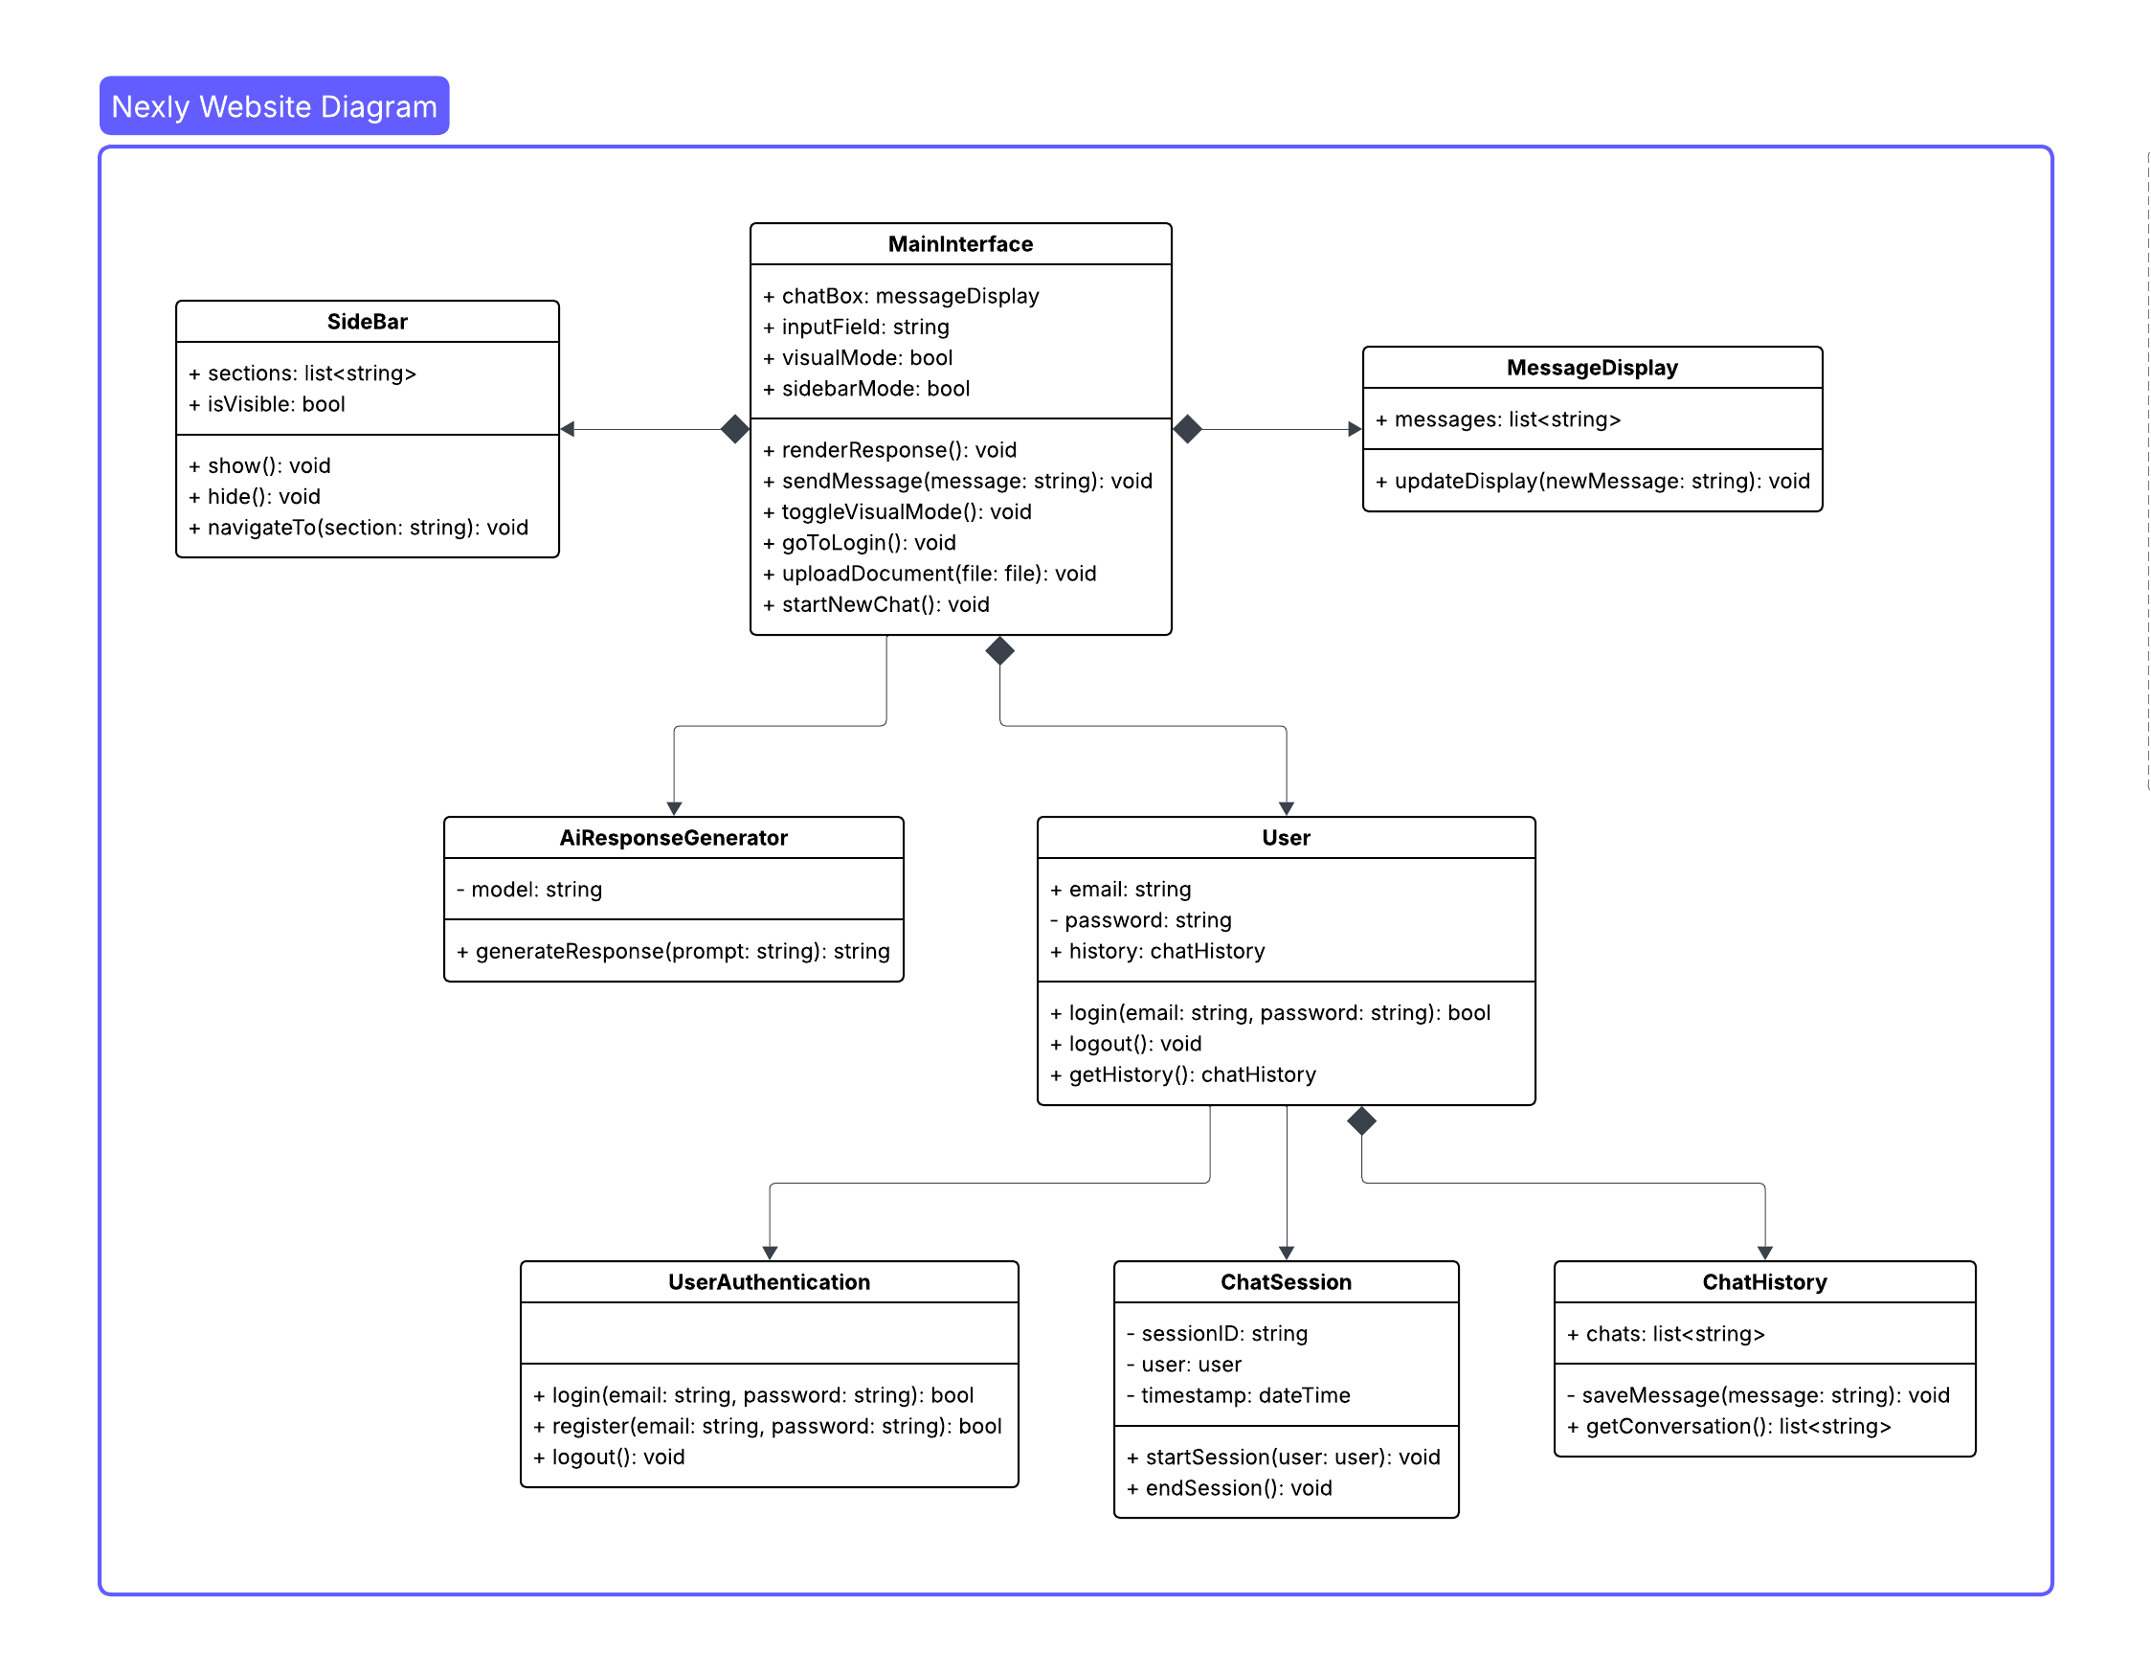

Figure 7.3: the class diagram for nexly web system

1. AiResponseGenerator is automatically initiated upon loading with the appropriate model.
2. User Authentication:
- login existing user information.
- authenticating user information.
- logout users.
3. Main Interface:
- Render and display AI responses.
- Send messages via sendMessage(message).
- Switch to dark or light mode.
- Navigate to login page.
- Upload documents to chatbox.
- Start a new chat .
4. MessageDisplay:
- Display new messages .
5. SideBar:
- Show or hide the sidebar.
- Navigate specific sections and chats.

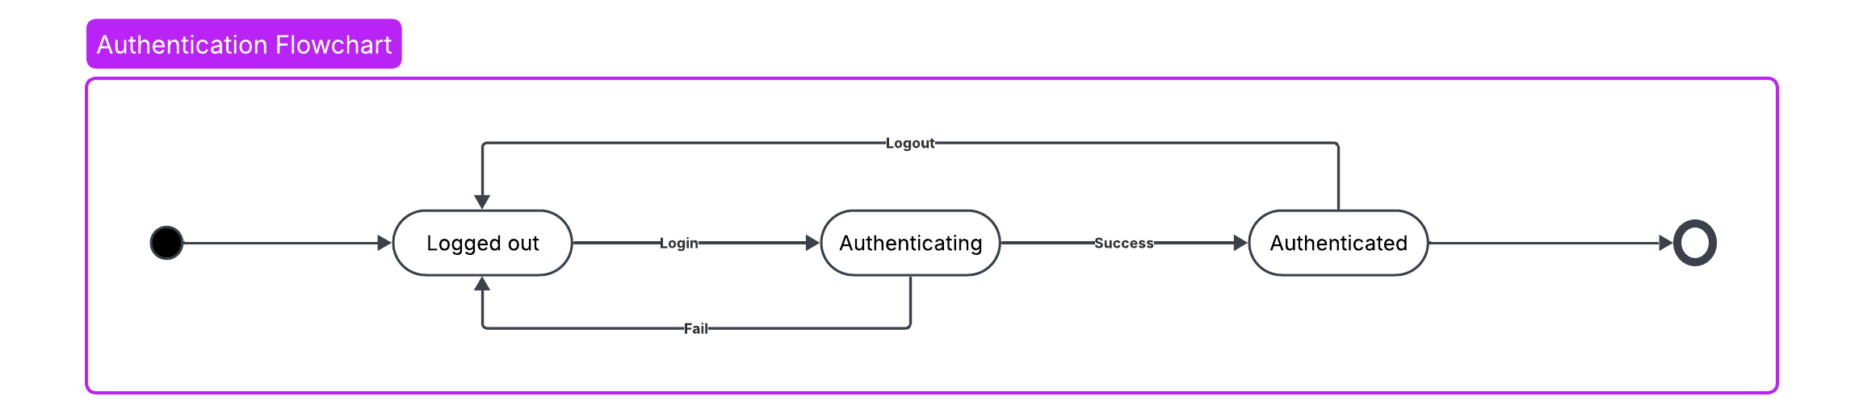
7.6 State Transition Diagram
Figure 7.4: state diagram for user authentication on Nexly web

- User starts logged out and has to input user information to proceed, if the user’s information doesn’t match, then it fails to authenticate and returns to the prior state.
- If users’ information matches then the account is authenticated and can proceed further.
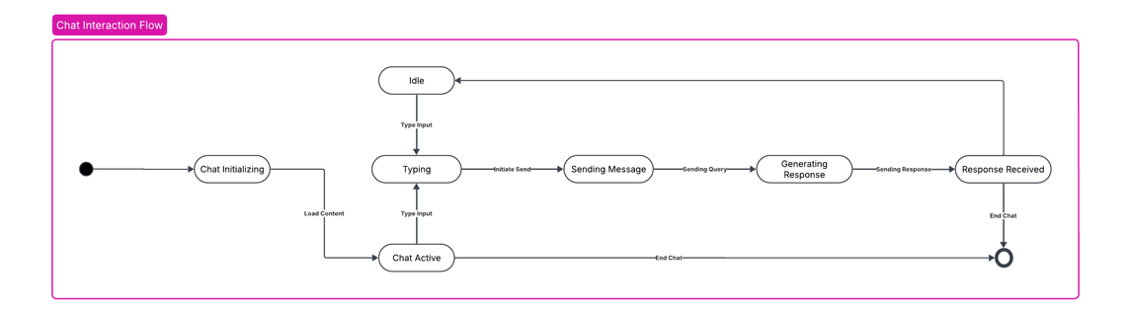
- Logged users have the ability to logout at anytime.
Figure 7.5: state diagram for chat interaction on Nexly web

- Chat is initialized and loads previously saved content
- User can type any input and request a query.
- RAG model will generate an appropriate response and output in the message display.
- The chatbot stay in idle until the user sends another query.
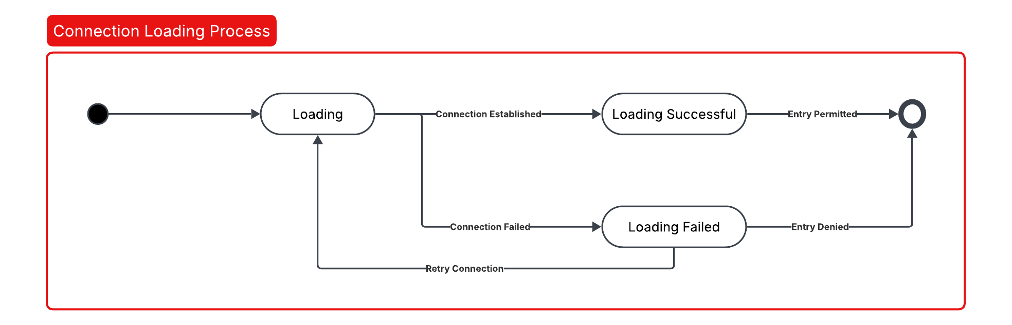
- Closing the window will end the chat.
Figure 7.6: state diagram for loading screen on Nexly web
- This following diagram demonstrates the connection loading process where an initial loading state leads to either a successful or failed connection.
- If the connection is successful, entry is permitted.
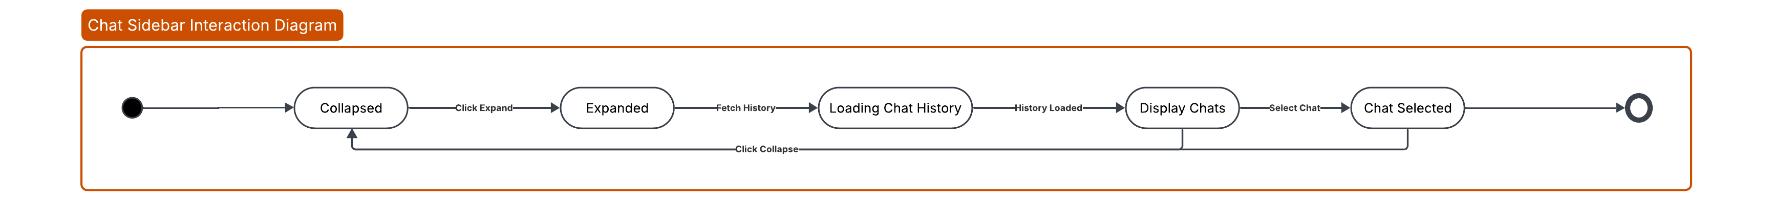
- If the connection fails, a retry option is available, or entry is denied. The process can loop back to retry loading if necessary.
Figure 7.7: state diagram for side bar on Nexly web
- It begins with displaying chat history, allowing users to either collapse the view or select a chat.
- Upon selection, the sidebar can be expanded or collapsed, and the history can be loaded.

Conclusion
Nexly began as a bold idea: could a handful of undergraduates build an intelligent, institution-aware advisor that actually feels helpful to students? Less than three months, thousands of scraped pages, and countless late-night debugging sessions later, the answer is a confident YES. We now have two fully-functioning MVPs—Nexly Web and Nexly Mobile—that already deliver 24/7, context-rich academic guidance drawn from real, up to date, and 90% accurate University of Sharjah resources.

What We Achieved

Pillar | Key Deliverables
End-to-End Data Pipeline | • Selenium crawler + BeautifulSoup cleaner  • PDF ingestion with llama-index  • 300 k+ chunks embedded via multi-qa-mpnet-base-dot-v1
RAG Engine (Web) | • Custom vector store → top-k retrieval → LLaMA 3.3 generation  • Confidence gate to curb hallucinations  • Average 26 % relevance uplift on test queries
Mobile AI Stack | • Gemini-Exa dual pipeline for low-latency answers  • Riverpod-driven Flutter UI with offline caching
Human-Centred UX | • Conversational memory, dark/light themes, error-tolerant flows  • Transparent citations and polite misuse handling
Security & Ethics | • Env-based key management, GDPR-aligned data handling, misuse refusal logic

Why It Matters
- Personalised, Real-Time Advising – Nexly transforms scattered web pages and static PDFs into an on-demand mentor that remembers the student’s context and speaks Arabic or English fluently.
- Scalable Architecture – Both MVPs are modular enough to swap in stronger embeddings, larger LLMs, or enterprise-grade vector databases without a complete rewrite.
- Institutional Alignment – Every answer is grounded in University of Sharjah sources, reducing misinformation risk and building student trust.

Honest Limitations
- No Large-Scale Test (Yet). Time and API credits will run out before we could unleash hundreds of simultaneous users. Real-world concurrency, latency spikes, and memory pressure remain unknowns, all to be decided if we host on a server.
- Public-Facing Data Only. Internal APIs (e.g., SIS, Blackboard) are not integrated, which caps Nexly’s depth on personalised schedules, grades, or holds in the current app version.
- Model Ceiling. mpnet-dot-v1 and a CSV vector store are pragmatic, but they cannot rival proprietary embeddings or FAISS-backed ANN search on million-chunk corpora.

Where We Go Next
- Scale & Stress-Test – Containerise the web backend, push to Kubernetes, and simulate campus-wide traffic to profile latency and cost.
- Vector DB Migration – Move embeddings to FAISS / Weaviate, enabling sub-100 ms retrieval at >1M chunks.
- SSO + Secure APIs – Integrate UoS Single Sign-On so Nexly can surface personalised schedules, exam venues, and tuition balances.
- Corrective RAG & Fine-Tuning – Let the pipeline auto-rephrase vague queries and fine-tune an LLM on UoS-specific corpora for even crisper answers.
- Full Feature Parity – Port the RAG workflow to mobile for identical answer quality across devices, then add push notifications, speech input, and Arabic localisation.

Final Thoughts
From an empty Git repo to a working cross-platform assistant, Nexly proves that modern LLM tooling can democratise high-quality academic support—even on a student budget. The web version showcases the power of Retrieval-Augmented Generation for authoritative answers, while the mobile app demonstrates how lightweight AI services can slot into everyday student life. Neither platform has hit its performance ceiling, but both establish a rock-solid foundation for future senior-project work, institutional pilots, and—hopefully—campus-wide adoption.
In short, Nexly is no longer a concept; it’s a living, breathing MVP that’s ready for the next climb. With deeper data access and rigorous testing, it can evolve into the always-on, multilingual advisor every University of Sharjah student deserves.

References
- Abdul-Rahman, A., & Abu-Naser, S. (2023). AI-supported academic advising: Exploring ChatGPT’s current capabilities and limitations. Education Sciences, 13(9), 885. https://doi.org/10.3390/educsci13090885
- Al-Khateeb, H., & Al-Tahat, M. (2023). Robo academic advisor: Can chatbots and artificial intelligence revolutionize auto-advising? Contemporary Educational Technology, 15(2). https://doi.org/10.30935/cedtech/13948
- Chukwuere, J. E. (2024). Developing generative AI chatbots: A conceptual framework for higher education. https://arxiv.org/pdf/2403.19303
- Exa AI. (2025). Web Search API documentation. Retrieved from https://exa.ai
- Google Developers. (2025, February 21). Gemini 2.0 Flash—release notes. Retrieved from https://developers.google.com

- Johnson, J., Douze, M., & Jégou, H. (2017). FAISS: A library for efficient similarity search and clustering of dense vectors [Software]. GitHub. https://github.com/facebookresearch/faiss

- Lewis, P., Perez, E., Piktus, A., Karpukhin, V., Goyal, N., … & Riedel, S. (2020). Retrieval-Augmented Generation for knowledge-intensive NLP tasks. Advances in Neural Information Processing Systems, 33 from https://arxiv.org/pdf/2005.11401
- LlamaIndex Team. (2024). Building RAG from scratch (open-source only!). LlamaIndex Docs. Retrieved from https://docs.llamaindex.ai/en/stable/
- Reimers, N., & Gurevych, I. (2021). multi-qa-mpnet-base-dot-v1 [Model card]. Hugging Face. https://huggingface.co/sentence-transformers

- Richardson, L. (2023). Beautiful Soup 4 documentation (Version 4.13). https://www.crummy.com/software/BeautifulSoup
- Selenium Project. (2024). WebDriver documentation from https://www.selenium.dev/documentation/
- Soliman, N., & Bakhit, Y. (2023). Role of AI chatbots in education: A systematic literature review. International Journal of Educational Technology in Higher Education, 20(15). https://doi.org/10.1186/s41239-023-00426-1
- Yan, S.-Q., Gu, J.-C., Zhu, Y., & Ling, Z.-H. (2024). Corrective Retrieval-Augmented Generation. https://arxiv.org/pdf/2401.15884

Acronyms Table
Acronym / Term | Definition (as used in this report)
AI | Artificial Intelligence – any computational technique that performs tasks typically requiring human cognition.
ANN | Artificial Neural Network – a model inspired by biological neurons, used here for language and vision tasks.
API | Application Programming Interface – a set of rules for requesting services (e.g., Gemini, Exa.ai, Groq).
CI/CD | Continuous Integration / Continuous Deployment – automated pipeline that builds, tests, and ships code on every commit.
CRUD | Create, Read, Update, Delete – basic data-handling operations exposed by Nexly’s thread manager and future UOS APIs.
CSV | Comma-Separated Values – lightweight tabular format used to persist embeddings during experimentation.
DOM | Document Object Model – browser representation of an HTML page; Selenium interacts with it to extract links.
FAISS | Facebook AI Similarity Search – a vector-database library for fast nearest-neighbour queries.
GPU | Graphics Processing Unit – accelerator used to embed text chunks and run LLM inference.
HCI | Human-Computer Interaction – discipline that informs Nexly’s mobile UX guidelines.
HTML | HyperText Markup Language – core language of web pages, cleaned by Beautiful Soup before chunking.
HNSW | Hierarchical Navigable Small World – FAISS index type that delivers sub-linear search across million-scale vectors.
JSON | JavaScript Object Notation – human-readable data‐exchange format (threads, settings, API payloads).
JWT | JSON Web Token – compact token format for stateless authentication; planned for SSO integration.
LLM | Large Language Model – transformer-based model (e.g., LLaMA 3.3, Gemini 2.0) powering Nexly’s reasoning.
LMS | Learning Management System – platforms like Blackboard; future Nexly versions will integrate with LMS APIs.
MVP | Minimum Viable Product – first fully functional release of Nexly (web + mobile) used for pilot validation.
NLP | Natural Language Processing – sub-field of AI dealing with human language understanding and generation.
OCR | Optical Character Recognition – technique for extracting text from scanned PDFs; disabled because UoS PDFs are native text.
PDF | Portable Document Format – common file type for university handbooks harvested and parsed by LlamaIndex.
RAG | Retrieval-Augmented Generation – pipeline that retrieves supporting text then feeds it to an LLM for grounded answers.
Corrective RAG | RAG variant that automatically rephrases low-confidence queries and retries retrieval before giving up.
SIS | Student Information System – authoritative source for schedules, grades; slated for future API integration.
SSO | Single Sign-On – centralized authentication (UoS login) planned to personalise Nexly responses.
Token | Smallest text unit recognised by the embedding or language model; ~4 characters on average for mpnet.
Context Window | Maximum number of tokens an LLM can consider at once (6 000 for Groq free tier in this project).
Embedding | Fixed-length numeric vector (768-D here) that captures semantic meaning of a text chunk or query.
Vector Store | Database that indexes embeddings for similarity search (CSV today; FAISS tomorrow).
Cosine Similarity | Metric used to rank embeddings; 1.0 = identical direction, 0 = orthogonal, –1 = opposite.
UI | User Interface – visual layer of the web dashboard and Flutter app.
UX | User Experience – holistic feel of interaction, latency, clarity, and accessibility across Nexly.
Exa.ai | Commercial semantic-search API supplying web snippets to the mobile pipeline when local RAG is unavailable.
Groq (mistral-saba-24b) | Hardware-accelerated LLM endpoint used for high-throughput generation during evaluation.

